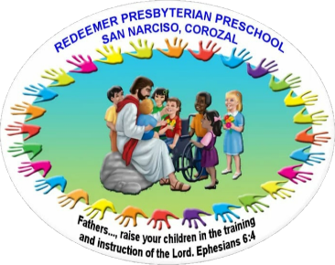

Name of Child: __________________ _________________ ______________
First name Middle Name Surname
Nick Name: _________________ Date of Birth: ______ _________ ________
(if any) day month year

Please circle: Boy or Girl Place of Birth: _________________________
Date of Admission: ___________________ Address of home: _______________________
Age of Admission: ____________________

Name of Father: _______________________ Work or phone no: ______________________
Occupation: __________________________

Name of Mother: _____________________ Emergency phone no: _____________________
Occupation: _________________________ Contact person for emergency: ______________

Name of Guardian: ____________________ Religion: ______________________________
Occupation: __________________________

Parents Married: Circle: Yes No Language Spoken at home: ________________

No of Children at Home:
Boys: _________ Age of oldest: _____________
Girls:__________ Age of youngest: ___________
Total: _________ Position of child: __________

Name of Preschool attended
Previously: __________________________
How long: ___________________________

Please circle: child is: Child is:
Sociable (sociable) Fluent
Friendly (Amistad) Stammer (tartamudear)
Fussy (alboroto) Converses freely
Shy (timido) Other
Likes to cry
State of health: ___________________ Special habits: _____________________
Toilet Trained: ___________________ Phobia: __________________________
Recurrent Illness: _________________ Physical problems: _________________
Allergies: _______________________ disabilities: _______________________
Special Medication: _______________ Immunization received Up to date:

Fees: 1. Registration fee (paid on registering) $20.00
2. Monthly fee per child (paid first Monday of each month: $10.00
3. Photo copy of birth certificate and social security card, immunization card
(N.B) we plan only 1 fund raising per year so as not to burden parents with expenses nor burden teacher with extra activities. We work to support each other.
Uniform: Boys – white shirt and navy blue pants.
Girls – white blouse and checkers skirt.
Personal items:
Please bring these items: 1 note book, 1 learning toy, (puzzle, alphabet…)
1 change of clothes (to leave at school in case of accident), colouring book, toothbrush, toothpaste, small plastic cup all in small container
Jumbo crayons, folder, 75 typing sheets (letter size); 05 pieces of foamy
(different colours), 01 Bristol board.
Optional donations: plastic plates, bowls, cups, pots, spoons for kitchen learning center, plastic storage
Container and apron.
Helper Day: once a month each family provides a female helper to:
- Assist the Teacher in classroom as needed
- Help serve the snack for morning session
- Help with bathroom needs of children; i.e. clean bathroom and room at the end of classes.
Student Pickup: Morning – bring child by 08:15am and be picked up at 11:30am
Afternoon – bring child by 01:00pm and be picked up at 03:30pm
NOTE: Please be on time, children get scared when they think they have been forgotten. On registration form write name of persons authorized to pick up child. On the event you send other person not on the form send us a note on whom you are sending to pick the child.
Birthday parties: If you plan to bring special food for your child’s birthday, please inform the teacher at least two days prior to the actual date.

____________________________________ _______________________________
Parent/ Guardian signature date

